MHCC NDIS ILC ‘Supporting Community Connection’ CEEP Project - Facilitator/Trainer Guide:
KEY TOPIC 5 – CREATING HEALING ENVIRONMENTS

Slide/s | Time | Key message/s | Resource/s
Prepare three labelled Butcher Paper sheets – What Might Lead to Traumatic Outcomes and Other Expectations and Triggers
Have copies of the resource MHCC ‘Trauma-Informed Events Checklist and Policy and Protocol’ available to share: http://www.mhcc.org.au/wp-content/uploads/2018/05/ticp_checklist_v4_20180222.pdf

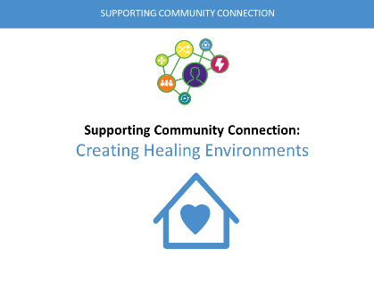  1. | 0-1  1 min | Welcome, etc.  For the next hour we will be thinking and learning about Creating Healing Environments’ and understanding the importance of creating safe and healing environments in trauma informed care and practice. | PPT in all sections as in the slide column
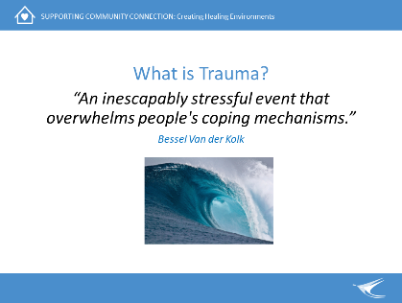  2. | 1-2  1 min | What is trauma  Inspiring quote – present and briefly discuss. Define trauma as being separate to the traumatic event.  Shift from the understanding of trauma as a direct experience into  Understanding it is any experience which overwhelms a person’s ability to cope and shapes their ongoing emotional experiences. It influences how safe they feel anywhere.  Emphasise key concepts of hopelessness, the person being overwhelmed, a combination of the event itself and the response of fear and helplessness.
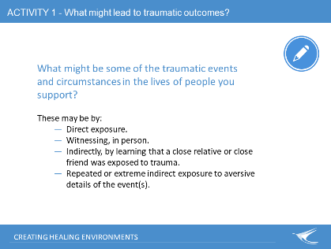  3. | 2-7  5min | Activity 1: What might lead to traumatic outcomes?  What might be some of the traumatic events and circumstances in the lives of people you support? (No details just generalised events)  Write two things on post-it notes.  The list may include (but not be exclusive to):  - Sexual abuse/sexual assault  - Domestic violence  - Physical abuse  - Emotional abuse  - Neglect  - Bullying  - Repeated humiliation  - Torture  After participant thoughts have been noted onto the butcher paper, reveal the next part of slide: These may be by:  - Direct exposure.  - Witnessing, in person.  - Indirectly, by learning that a close relative or close friend was exposed to trauma.  - Repeated or extreme indirect exposure to aversive details of the event(s), usually in the course of professional duties.  Start some discussion around whether people were aware of the last point. This can be experienced by service workers who frequently hear traumatic stories from people they support. It is Vicarious Trauma. | Post its and  Butcher paper pre-labelled with:  What Might Lead to Traumatic Outcomes?
4.  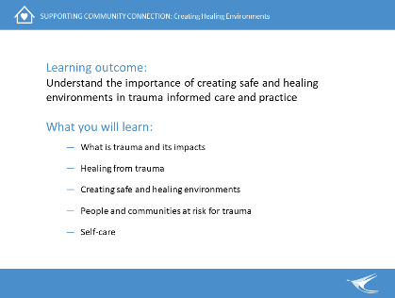 | 7-8  1min | Learning outcome: Importance of trauma informed care and practice  What you will learn:  - What is trauma and its impacts (combination of the event/s and the response and impacts of fear and helplessness)  - Healing from trauma  - Creating safe and healing environments  - People and communities at risk for trauma  - Self-care  Ask if there are any other expectations they would like from the training. | Butchers Paper – Other Expectations
5.  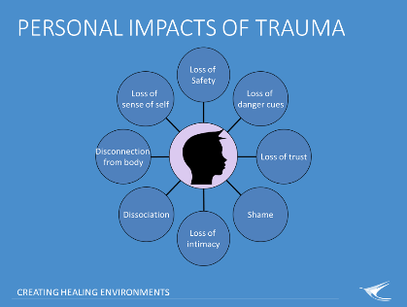 | 8-13  5min | Firstly, some of the prevalence of trauma  - Trauma is widespread across all socio-economic, ethnic and cultural boundaries.  - Hard to gather statistics in some communities due to secrecy, shame, and fear.  - Trauma can be trans-generational for individuals and it can affect whole communities.  - Particularly problematic in Aboriginal and Refugee Communities, in rural and remote communities, amongst veterans and people who experience Domestic Violence, the LGBTIQA+ community and people living with disabilities.  Some Personal Impacts of Trauma  Trauma frequently leads to diversity of mental health (MH) distress and of co-occurring problems.  Impacts of trauma are highly individualistic. Trauma can affect any or every aspect of a person’s life. The impacts of trauma on a person can be physical, cognitive, behavioural, emotional, social, and spiritual.  Some of these impacts may be the person experiencing:  Loss of safety - the world becomes a place where anything can happen and affects thoughts, memory, beliefs, and sense of self.  Loss of danger cues - How do you know what is dangerous when someone you trust hurts you and this is then your ‘normal?’  Loss of trust - This is especially true if the abuser is a family member or a close family friend.  Shame - Huge, overwhelming, debilitating shame. As a child, even getting an exercise wrong at school can trigger the shame. The child may grow into an adult who cannot bear to be in the wrong, because it is such a trigger.  Loss of intimacy - For survivors of sexual abuse, sexual relationships can either become something to avoid or are entered into for approval (since the child learns that sex is a way to get the attention they crave) and the person may be labeled ‘promiscuous.’  Dissociation - Often, to cope with what is happening to the body during the abuse, the person will dissociate (disconnect the consciousness from what is happening). Later, this becomes a coping strategy that is used whenever the survivor feels overwhelmed and again feeling those effects on the body.  Disconnection from body - Survivors of sexual and physical abuse often have a hard time being in their body. This disconnection from the body makes some therapies known to aid trauma recovery, such as yoga, harder for these survivors.  Loss of sense of self - One of the roles of the primary caregiver is to help us discover our identity by reflecting who we are back at us. If the abuser was a parent or caregiver, then that sense of self is not well developed and can leave us feeling phony or fake.  Reference: https://www.echotraining.org/
6.  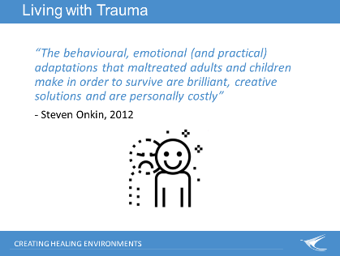 | 13-18  5min | Living with Trauma  People will go to great lengths to soothe the stress response.  Ways people have survived and soothed their stress response work in the short term but can have long term negative outcomes.  Facilitate a brief discussion based on what participants already know about the strategies (coping mechanisms) that people use to manage their distress. Write on WB  Discuss how these strategies can be viewed differently by others or become a source of shame  Behaviours can help people cope by:  - attacking or pushing others away  - defending or avoiding potential threats  - changing or controlling experiences  The consequences of trauma and adaptations to cope with it, often lead to a number of mental health psychosocial difficulties. Add the following if not already noted from discussion:  - Poor physical health  - Substance abuse and misuse  - Self-harming behaviours  - Suicidality  - Dysfunctional relationships, poor self-esteem  - Poor educational outcomes, poverty  - Contact with criminal justice system  Discuss how risky behaviour can be a coping strategy.  Self-harm is risky behaviour – a way of self-soothing. Especially if there was early childhood trauma. This is when we learn the self-soothing mechanism. This mechanism can be disrupted by trauma, so self-soothing is disrupted. This behaviour needs help. | White board - to write some coping mechanisms down
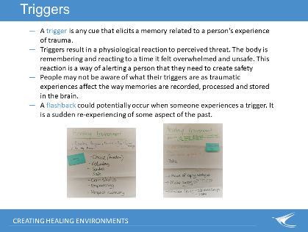  7. | 18-20  2min | Triggers are cues that elicit memories held within the body from past experiences of trauma.  Triggers can be specific to an individual or they can be blanket triggers which are more likely to affect a larger number of people who have experienced trauma  If a person’s experience of mental distress did not originate from a traumatic experience – their contact with the MH system and living with stigma and discrimination can be a traumatising experience in itself  Activity: Group Brainstorm:  Group list some factors that could be triggering or retraumatising for people using your service around the following headings:  Individual Workers.  Organisational Policies.  Physical Environment. –  these may be similar to earlier activity “What may lead traumatic outcomes?”  Group Brainstorm to gather prior knowledge:  What signs might you notice if someone is triggered or struggling to cope with their experiences of trauma?  Some examples may include:  - Being easily startled, jumpy or ‘on edge’  - Feeling shut down or cut off or numb  - Finding it hard to calm down after becoming upset  - Finding it difficult to ‘get moving’ | Record onto butcher paper pre-labelled: Triggers  Write on white board – keep visible for Window of Tolerance.
Remain on previous slide  Draw this diagram on whiteboard or have it pre-drawn-  Window of Tolerance | 20-25  5min | Window of tolerance  is a term used to describe the zone of arousal in which a person is able to function most effectively.  When people are within this zone, they are typically able to readily receive, process, and integrate information and otherwise respond to the demands of everyday life without much difficulty.  The window of tolerance is the optimal zone of autonomic and emotional arousal that supports a person to function effectively and also supports their wellbeing.  A way to understand what’s happening when someone gets triggered and how we can help that person to return to a ‘safe space’ and regulate their emotions.  Our window of tolerance can be narrow or wide and is different for all people at different times in our lives.  When a person is triggered, they have an automatic bodily/biological response to the perceived threat that moves them out of their window of tolerance for a situation.  To understand the “window of tolerance” discuss how people with lived experience of trauma might present to services when experiencing hyper-arousal and hypo-arousal.  Hyper – is excessive or too much (tension, shaking, hyper vigilance, startled, high emotions)  Hypo – is not enough or too little response (numb, collapse, difficult to get moving, flat emotions)  Using the group brainstorm from triggers and struggling to cope signs above, label the signs as Hyper or Hypo:  - Being easily startled, jumpy or ‘on edge’ - Hyper  - Feeling shut down or cut off or numb - Hypo  - Finding it hard to calm down after becoming upset - Hyper  - Finding it difficult to ‘get moving’ - Hypo | Categorize the writing on white board – from the ‘Signs of being triggered’ activity above
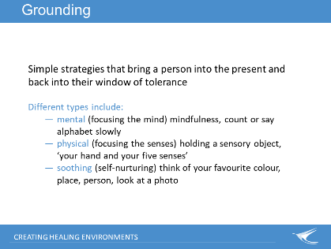  8. | 25-27  2min | Grounding – when someone is distressed  Grounding techniques can be helpful to assist a person to come back to their window of tolerance.  Grounding is a significant practical tool and resources that workers can use themselves (for example to remain present or to sooth after a distressing interaction) as well as for trauma survivors.  During times of distress, use clear questions/instructions, small sentences, and simple language.  A good relationship and knowledge of the person can give you a better understanding of how to support them when experiencing distress.  If you notice something about a person is different–ask them “Is there something I can do?”  Ask if they need time out or some space.  Discuss grounding techniques. Ask for examples from room  May follow with examples of each one on the slide.  - mental (focusing the mind) – mindfulness, read something, saying each word to yourself. Or read each letter backwards so that you focus on the letters and not on the meaning of the words. Count to 10 or say the alphabet, very s…l…o…w…l…y.  - physical (focusing the senses) – Your hand and your five senses, Self-holding technique Carry a grounding object in your pocket, which you can touch whenever you feel triggered. Notice your body: the weight of your body in the chair; wiggle your toes in your socks; the feel of your chair against your back, etc.  - soothing (self-nurturing) - Think of your favourite colour, animal, season, food, time of day. Picture people you care about (e.g. your children), look at a photograph. Remember a safe place. Describe the place that you find so soothing.
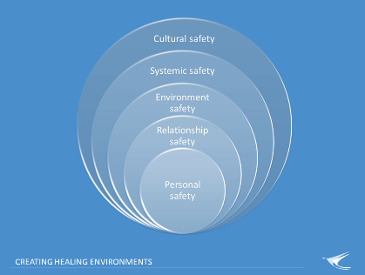  9. | 27-30  3min  30-35  5min | Safety is a critical part of a healing environment. Creating a safe space for someone is most important.  Healing and health and wellbeing can only occur when (relative) safety has been achieved - not only when the threat has been removed, but when clear signals of safety are received by the body and the brain.  Safety is also necessary for maintaining the window of tolerance, for planning, paying attention, retrieving information, and enjoyment…  To maintain a healing environment, it is essential to recognise the importance of keeping safety in mind at all times.  How to create safety?  Ask the person “Is there somewhere else you would like to go?” or “Is there something I can do?”. They may just need time out or some space.  Safety” in trauma informed care is more than just physical safety.  Safety means different things to different people. Safety is a safe physical, psychological and emotional environment where basic needs are met.  If you do not know – ask the person  Safety means not only personal safety but safety within relationships, environments, systems and cultural safety.  Safety in Relationships – reflect upon these thoughts for yourself  - What does a ‘safe relationship’ mean to you?  - What qualities are important in the other person?  - How do you know when you are ‘safe’ in that relationship?  - How can you promote these relationships in your work?  Use these questions to reflect upon the qualities needed in relationships for them to be perceived and experienced as safe.  RICH relationships:  To reflect upon how safe relationships are supported (or not) in the workplace:  Draw the acronym R.I.C.H down along the WB. Ask participants to suggest what the letters may stand for -  R Do they feel respected? By me? By the service? Is the respect mutual?  I Is information being conveyed honestly and transparently? Is all important information being conveyed?  C How are we connected? What barriers exist for connection? What is this person’s history of social inclusion?  H How am I conveying hope? How does the service convey hope? Do I know what the person’s hopes are for themselves?  Trauma Informed Conversations  Holding trauma informed conversations – value the persons experience.  - Ensuring the person is currently safe  - Addressing responses to feelings of distress  - Recognise the past can influence the present but stay in the present.  - Share information openly – knowledge is power.  - Assume (and value) self-knowledge and expertise.  - Value coping strategies (even those that are costly or over-developed or conflict with your values).  - Support self-direction and choice.  - Each person will have different knowledge and learning needs. Take your cues from the person.  Conversations should not be about giving advice or imposing perceived expertise, but about valuing the person’s lived experience expertise and offering information in a way that may be useful to the person seeking assistance.  Allow time for the survivor to calm down and take perspective. Trauma survivors often have difficulty regulating emotions and take longer to calm down.  Give what you also need to receive: listening, empathy, and empowerment.  Tell the person that they do not have to answer any question if they do not want to | On the white board -write some key words from (left)  On the white board – write down the page:  R  I  C  H  Complete the words for the acronym on the white board
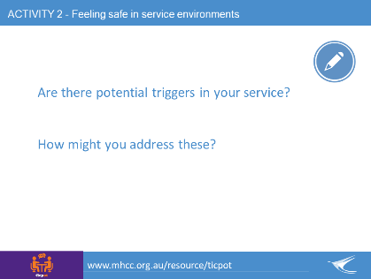  10. | 35-40  5min | Feeling safe in service environments  Even some apparently 'well intentioned ‘' actions within a service can induce trauma and re-experiencing of trauma.  Consumers/survivors can be re-traumatised by contact with services.  Some practices are traumatising in and of themselves.  Some people might perceive workers to:  - hold secret knowledge and information  - betray their trust  - invalidate their experience and define their story for them  - take power away from them  - control them  Activity Question: Add to the existing list on butcher paper  - Are there potential triggers in your service? How will you know?  - How might you address these?  If you do not know – ask the person:  ‘What can I do to help you feel safe?’ ‘Are you okay if we talk about this?’  Safety in environments is a pre-requisite for healing and recovery.  Resource: TICPOT - http://www.mhcc.org.au/resource/ticpot/  Trauma-informed care and practice organisational toolkit  A FREE quality improvement audit and implementation resource for developing a trauma-informed organisational and practice culture. | Add to the existing activity  Butcher paper  Pre-labelled with: Triggers
11.  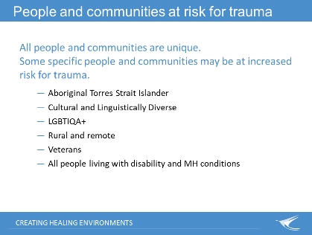 | 40-42  2min | People and communities at risk for trauma  Trauma is widespread across all socio-economic, ethnic and cultural boundaries.  While all people and communities are unique there some specific people and communities that may be at increased risk for trauma:  - Aboriginal Torres Strait Islander – due to history of colonisation and experiences since that time  - Cultural and Linguistically Diverse – especially for refugees with exposure to traumatic violence  - LGBTIQA+ - identity, belonginess and high suicide rate  - Rural and remote – drought and high suicide rate  - Veterans – exposure to traumatic violence and poor post event support?  - People living with disabilities  Impact of collective trauma and intergenerational trauma can be reflected in a community and seen as:  - Fear, vigilance and hyper-arousal  - Numbing, avoidance and withdrawal  - Loss of memory, impaired learning  - Role confusion, breakdown of boundaries and social norms  - Loss of sense of belonging  - Lateral violence  Reflecting on culture, gender and privilege  - What influences your interactions with people?  - How do you recognise advantages that you may have as a result of your culture, gender, sexual orientation, age, ethnicity or upbringing etc.  - What about the disadvantages?  - How might people you support perceive these?  - How do you address this?  - How does it feel to address this?
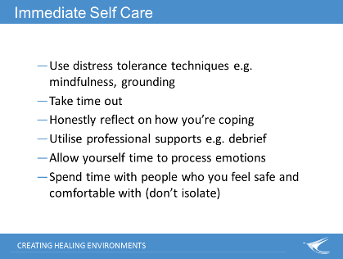  12. | 42-45  3min | Immediate Self-Care  Importance of self-care in healing/nourishing when helping someone who has experienced trauma.  There is the risk of vicarious trauma due to the exposure to aversive details of traumatic events. This can have the same impacts on a person as direct exposure or witnessing traumatic events.  Discuss immediate self-care measures after a difficult interaction.  Discuss workplace supports by first asking group for examples that they are aware of in their workplace:  - Debriefing  - Supervision  - EAP (Employee Assistance Program)  - Flexitime  To wrap up section - ask people to think about one self-care practice:  - one they can do directly after the course and  one they have to look forward to later e.g. the weekend.
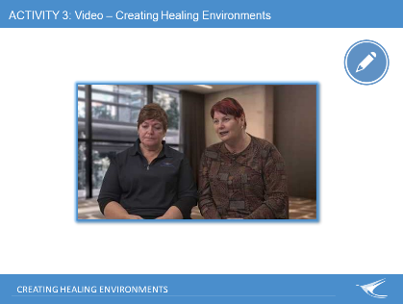  13. | 45-55  10min | Video – Creating Healing Environments  Show and discuss video.  For discussion: How are the experiences of Community Workers and other paid and unpaid supporters in this video related to the importance of trauma informed care and practice?
14.  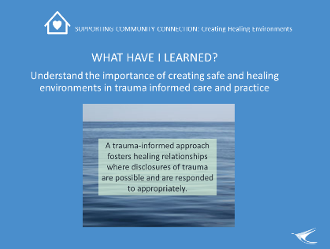 | 55-60  5min | Revisit whether the learning outcome for this key topic has been achieved: Understanding the importance of creating safe and healing environments in trauma informed care and practice? (and also see slide 4).  Remind learners that we started off by exploring what might lead to traumatic outcomes? And triggers awareness.  Explore if the learning key topic content has supported achieving the learning outcome and other learning key topic expectations of this session that were put on Butchers Paper earlier.  Any questions? | Revisit posted butchers paper from earlier in the topic:  Other Expectations  What Might Lead to Traumatic Outcomes?  Triggers
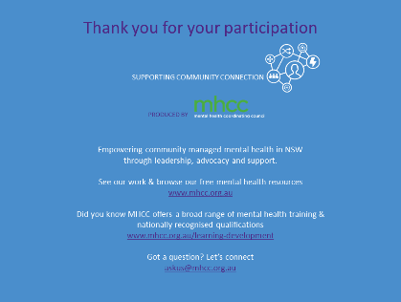  15. |  | Acknowledge MHCC’s development of the learning resource and encourage others to learn more about who MHCC is and what they do:  - Peak body for the community managed mental health sector in NSW  - Registered training organisation.

