MHCC NDIS ILC ‘Supporting Community Connection’ CEEP Project - Facilitator/Trainer Guide:
KEY TOPIC 3 – SUPPORTS AND SERVICES

Slide/s | Time | Key message/s | Resource/s
Prepare four labelled Butcher Paper sheets: Types of Supports & Services, Other Expectations and Practicing Warm Referrals.
Familiarise yourself with, and be prepared to speak about, the World Health Organisation (2018) “Right of everyone to the enjoyment of the highest attainable standard of physical and mental health”: https://www.mhcc.org.au/wp-content/uploads/2019/09/Right-Physical-MHWHO-2019-.pdfT This resource is likely too long for most learners but reinforces that community and mainstream supports and services need to be accessible for (i.e., not discriminate against and exclude) people living with disabilities; including psychosocial disability related to a mental health condition.

1.  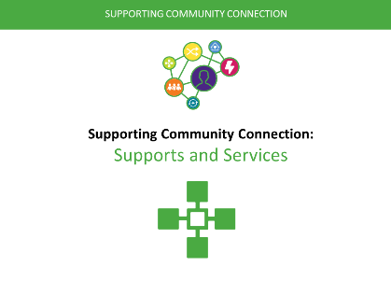 | 0 – 1 min  (1 min) | Welcome, acknowledgement/s, etc.  For the next hour we will be thinking and learning about the types of ‘Supports and Services’ that are available for people living with mental health conditions outside on an NDIS funded package and crisis mental health services.  Explain that learners will not learn about specific supports and services available in their local communities but service types so that they can become knowledgeable about these in their local communities (you may want to reinforce this message against slide 4 and when considering ‘Learning Expectations’).  Explain that it is important that people living with mental health conditions are supported to have a fulfilling life outside of funded NDIS services and crisis mental health services in the communities of their choice including having access to a full range of supports and services. | PPT in all sections as in the slide column  PPT handout at 3 slides per page and note taking lines.
2.  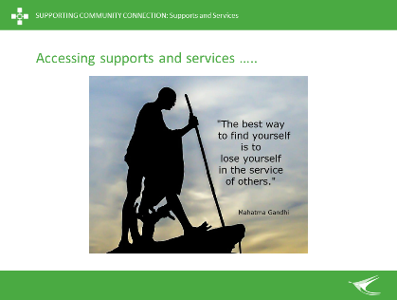 | 1 – 3 min  (2 min) | Reflection  Briefly present and briefly discuss this inspiring quote: ‘The best way to find yourself is to lose yourself in the service of others’ (Mahatma Gandhi).  Ask: Are you aware of all the supports and services in your local community.  Answer: No-one can be expected to be aware of all the supports and services in their local communities; especially as things are changing so often to help better address people’s needs. This is true for service providers as well as clients and their families, carers and kinship groups.  Explore how role modelling finding supports and services, and empowering others to find supports and services, is a powerful helping tool.  Link to importance of seeking to have a greater knowledge of supports and services outside of NDIS funding and crisis mental health services (topic learning outcome introduced in Slide 4).
3.  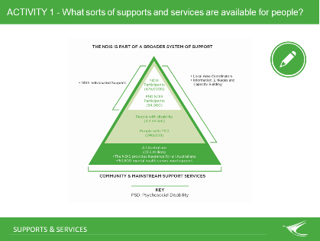 | 3 – 10 min  (7 min) | ACTIVITY 1: Note: Do not show this slide before asking and exploring the following question.  Ask “What supports and services can you think of that might be available for people living with mental health conditions outside on a funded National Disability Insurance Scheme (NDIS) package or acute mental health services”? Explain that ‘acute’ means both hospital and community-based mental health crisis services for people who have an urgent need for treatment.  List on Butcher’s Paper a few people’s identified supports and services. You might also highlight any comments related to the need for everyone to acquire a greater knowledge of supports and services outside of the NDIS and MH.  After the activity present the slide. Explain that there are many more people living with mental health conditions than will receive NDIS packages (i.e. 64,000 of 290,000 will get an NDIS package with the gap being 226,000 people) as well as 153,600 MH carers who need help.  Explain we all need to strengthen our knowledge about community and mainstream supports and services to better help people living with mental health challenges. That is, that we need to reduce reliance on NDIS funded services and acute/crisis mental health services to help people have more fulfilling lives in the communities of their choice. | Butcher’s Paper - Types of Supports & Services  Markers  Blu Tac
4.  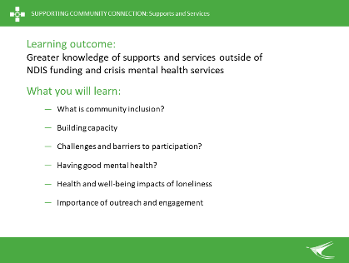 | 10 – 12 min  (2 min) | What will I learn?  Introduce learning topic and learning outcome: Greater knowledge of supports and services outside of NDIS funding and crisis mental health services.  Briefly reference what you will learn and then ask if people have other expectations of this session. Document other expectations on Butchers Paper (this will also be revisited at the end of the module).  Reinforce that people will not be learning about specific services in their community but types of services that they are encouraged to learn more about. | Butcher’s Paper – Other Expectations  Markers  Blu Tac
5.  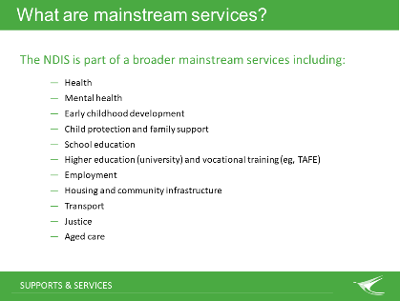 | 12 – 15 min  (3 min) | What are mainstream services?  The NDIS defines mainstream services as non-disability specific services and organisations, e.g., health, mental health, education, employment, justice, housing and child protection services.  Explain that the NDIS is part of a broader system of supports and services that should be available for all Australians, including people living with mental health challenges.  Explain that the government identifies 11 categories of ‘mainstream’ services as being available to all Australians including people living with disabilities or other forms of diversity (i.e., ‘diversity includes ATSI, CALD, GLBTIQA+, rural/remote).  Explore how this list compares to that placed on the Butchers Paper during Activity 1 (there are likely to have been fewer support and service types identified). Ask people what they might add to the list and add them. | Butcher’s Paper - Types of Supports & Services
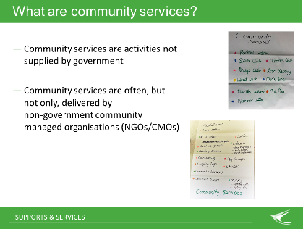  6. | 15 – 18 min  (3 mins) | What are community services?  The NDIS defines community services as activities not supplied by government groups, available to everyone in the community, e.g., social, study and sporting interests. (‘Supplied’ means that government does not either directly provide them of fund others to provide them).  Explain that community services are often delivered by non-government community managed organisations (NGOs/CMOs); but also not-for-profit community groups, private-for-profit service providers, etc. Explain that:  - Many community organisations/services/groups receive funding and/or in-kind donations from non-government sources (e.g., volunteers, donations, foundations, philanthropic funds, etc.)  - Government funded community services are also ‘mainstream’ supports & services (and workers may or may not identify as being ‘Community Workers’).  Community supports and services include, for example:  - family, friends and kinship groups  - local neighbourhood activities  - civic and social organisations  - arts and cultural activities  - sports and recreation events  - churches and other spiritual centres  - a range of voluntary activities  - Digital platforms like ‘Meet Up’, etc.  Say that are untapped supports within our communities and encourage people to learn about, and connect themselves and others, with them.
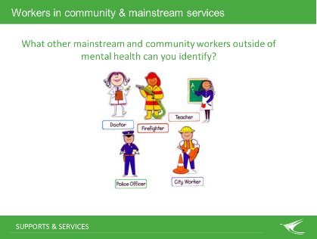  7. | 18 - 23 min  (5 min) | Brainstorm – Workers in community and mainstream services  This slide shows some community/mainstream workers.  Ask: What other community/mainstream workers can you name?  Examples are limitless and include: Community Support Worker, Emergency Services Worker, Housing/ Homeless Worker, Alcohol and Drug Officer, Child Protection Officer, Community Development Officer, , Counsellor, Crisis Intervention Worker, Disability Services Officer, Domestic Violence Worker, Family and Community Services Worker, Juvenile Justice Officer, Multicultural Support Officer, Residential Care Officer, Welfare Worker, Youth Worker, etc.  Explain that people can struggle to name community and mainstream workers that can help people living with mental health challenges. One reason why is that they have learned, over time, to turn to mental health services to meet a range of life needs and, more recently, to NDIS funded supports.
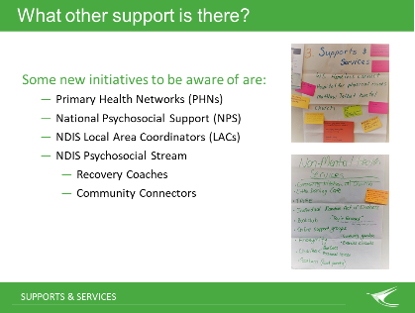  8. | 23 – 28 min  (5 mins) | What other support is there?  Say that there is change happening for human services to be more responsive to people’s and community needs. It can be challenging to keep up with changes and they need to be embraced as there will likely never be enough funded services for everyone that needs them.  Explain that we need to move away from just referring people to crisis/acute mental health services or the NDIS. People need, and usually want, more than just funded services, hospital and medication in their life.  Some new directions to be aware of are:  - Primary Health Networks (PHNs) - There are 31 PHNs across Australia. PHNs are about provide ‘the right care’, ‘in the right place’, ‘at the right time’ within local communities.  - National Psychosocial Support (NPS) - Australia PHNs work with CMOs to provide new program called the NPS service. These programs can help people living with mental health challenges who are ineligible, or do not want to apply, for NDIS funded supports and services.  - NDIS Local Area Coordinators (LACs) - LACs work in partnership with the NDIA to help people access the NDIS. They help people to connect with community and mainstream supports and services.  - NDIS Psychosocial Stream – the NDIA have introduced a ‘psychosocial stream’ to help people living with mental health challenges access and navigate the NDIS.  - Recovery Coaches – The NDIS introduced Psychosocial Recovery Coaches on 1 July 2020. These are people with lived experience of mental health challenges and recovery that will help others (for people with NDIS funding).  - Community Connectors – These are being introduced for people living with, or at risk to develop, psychosocial disability related to mental health conditions.  Explain that it is simply not possible for any one person or organisation to be aware of all the supports and services that a person living mental health challenges might want and benefit from. Knowing, and being able to role model, where to go to find out about available supports and services is important in empowering people living with mental health challenges to self-direct their lives.
9.  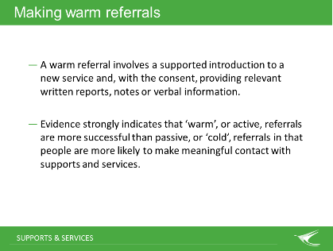 | 28 – 30 min  (2 min) | Warm Referrals  We have been exploring the roles and contributions of Community Workers, and other community and mainstream supports are services, to help people living with mental health challenges. All supporters – both paid and unpaid - need to know how to make ‘warm referrals’ to help people living with mental health challenges to better access community and mainstream and services.  A warm referral involves a supported introduction to a new service (e.g., supporting the individual to make the initial contact with the new service or provider) and (with the consent of the individual) providing relevant written reports, notes or verbal information.  Evidence strongly indicates that ‘warm’, or active, referrals are more successful than passive, or ‘cold’, referrals in that people are more likely to make meaningful contact with supports and services.
10.  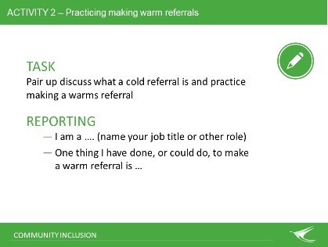 | 30 – 36 min  (6 min) | Activity 2 – Practicing Warm Referrals  Introduce Activity 2 and ask people to form pairs.  Ask people to make a statement to one another “I am a Community Worker or other paid/unpaid supporter (instruct them to note as many as roles as apply). One thing I have done, or could do, to make a warm referral is …”. Instruct them to write their statements down on coloured post it notes. Provide an example for people to follow. For example. “I am a Homeless Worker and also help to support a brother who is living with Schizophrenia. One thing I have done to make a warm referral is go with my brother, and also homeless people I see at work, to local GROW support groups. This helped them get to know other people and become comfortable going on their own”.  Ask for a few people to share their statements and then for all to post them on Butcher’s Paper titled ‘Practicing Warm Referrals’. Read out a few other examples posted. | Butcher’s Paper – Practicing Warm Referrals  Post It Notes  Markers  Blu Tac
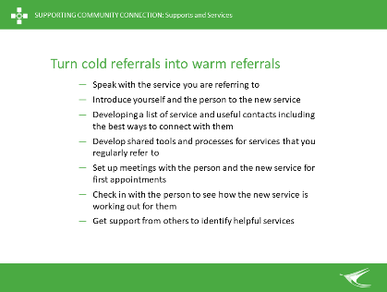  11. | 36 – 38 min  (2 min) | Turn cold referrals into warm referrals  Say “Here are some ways of turning ‘cold’ referrals into ‘warm’ referrals’.  - Speaking directly to the service you are referring the person to and checking if it seems right for them  - Introducing yourself and the person to the referral agency and providing a verbal and/or written handover (with the person's consent)  - Developing a referral pathways list for your service that identifies and shares useful contacts  - Developing shared assessment or referral tools and processes for services that you regularly refer to (and those that regularly refer to you)  - Setting up joint meetings with the person and the new service for initial appointments  - Following up with the person to see how the referral to the new service or support is working out  - Getting support from colleagues to help identify appropriate services for referrals in particular locations or for specific issues.  How does this compare to some of the ideas identified previously (not all are likely to have been identified).
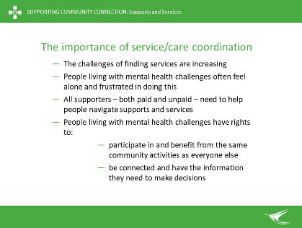  12. | 38 – 40 min  (2 min) | Service/care coordination  Service/care coordination, including making warm referrals, is essential for helping people to navigate what is an increasingly complicated health and social services system  - The challenges of finding needed supports and services are increasing  - People living with MH conditions are left to navigate a system that is complex, uncoordinated and not tailored to meet their needs  - It is important for all supporters to help people navigate supports and services  - People experiencing MH conditions have a right to participate in and benefit from the same community activities as everyone else and be connected and have the information they need to make decisions (trainers need to know that these are important as these are the CEEP Project ILC outcomes).  Emphasise that service/care coordination is a skill that all community and mainstream workers need to have. There are learning opportunities available to learn these skills.
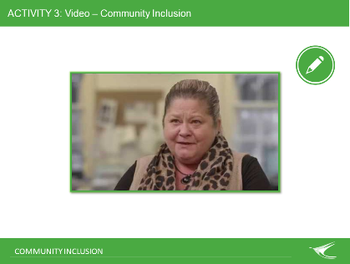  13. | 40 – 50 min  (10 min) | Activity 3 - Show and discuss video.  For discussion: How are the experiences of Community Workers and other supporters in this video related to the importance of people accessing supports and services to be included in the communities of their choice?  Note: The end of the video will prompt for:  - Who is my local PHN?  - Who my local LAC (organisation)?  If these questions have not come up across the topic be prepared for them to now.  People may also want to know:  - Who is my local NPS?  The ‘Supporting Community Connection’ Good Practice guide has a list of the 31 PHNs nationally and NSW examples of LAC and NPS organisations. To deliver this topic outside of NSW you will want to know what organisations provide LAC and NPS services in your area OR perhaps be prepared to role model finding this out.
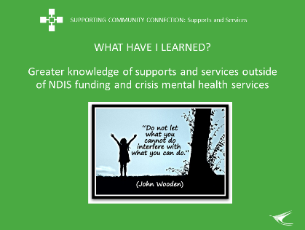  14. | 50 – 59 min  (9 min) | What have I learned?  Revisit whether the learning outcome for this module has been achieved: Greater knowledge of supports and services outside of an NDIS funded package and crisis/acute mental health services (and also see slide 4).  Remind learners that we started off by exploring the importance of being able to work within your local community to understand the range of supports and services available to people and about the rights of people living with mental health challenges to access them (and that no one person would ever be expected to be able to know all of them!). Revisit Butcher’s Paper for Slide 3 “What supports and services can you think of that might be available for people living with mental health conditions outside on a funded NDIS package crisis/ acute mental health services” and Butcher’s Paper for Slide 4 ‘Learning Expectations’?
15.  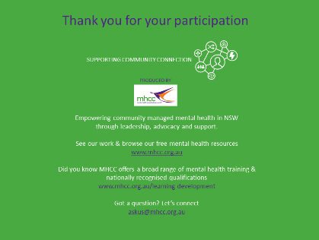 | 59 – 60 mins  1 min) | Concluding slide  Acknowledge MHCC’s development of the learning resource and encourage others to learn more about who MHCC is and what they do:  - Peak body for the community managed mental health sector in NSW  - Registered training organisation.

This resource, and the importance of using rights-based approaches, when working with people with mental health challenges is introduced in the ‘Community Inclusion’ key topic: “Good mental health and well-being cannot be defined by the absence of a mental health condition, but must be defined instead by the social, psychosocial, political, economic and physical environment that enables individuals and populations to live a life of dignity, with full enjoyment of their rights and in the equitable pursuit of their potential.”
A resource for facilitators to learn more about this is: Council of Australian Governments (2015). Principles to Determine the Responsibilities of the NDIS and Other Service Systems: https://www.coag.gov.au/sites/default/files/communique/NDIS-Principles-to-Determine-Responsibilities-NDIS-and-Other-Service.pdf

