MHCC NDIS ILC ‘Supporting Community Connection’ CEEP Project - Facilitator/Trainer Guide:
KEY TOPIC 1 – WHAT IS RECOVERY?

Slide/s | Time | Key message/s | Resource/s
Prepare three labelled Butcher Paper sheets – What Does Recovery Mean to You? and Other Expectations and Recovery - Meeting Expectations
Have copies of the MHCC ‘Recovery Oriented Language Guide’ (2018) also available to share at www.mhcc,org.au
It is vital that words used in recovery-oriented practice approaches convey hope and optimism, and support and promote a culture that fosters recovery.

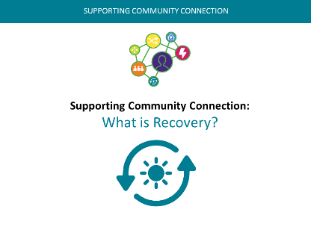  1. | 0 – 1 min  (1 min) | Welcome, acknowledgements, etc.  For the next hour we will be thinking and learning about ‘What is Recovery?’ and understanding the importance of living a life with hope, purpose and meaning when healing from the impacts of a mental health condition. | PPT in all sections as in the slide column
2.  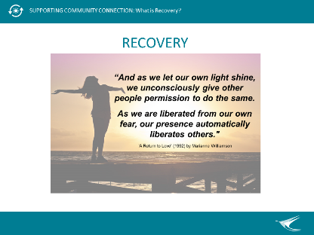 | 1 – 2 min  (1 min) | Inspiring quote – present and briefly discuss. Link to notions of living a life with hope, purpose and meaning when healing from the impacts of a mental health condition.  In the ideal world, Community Workers and others could:  - feel confident about working alongside people living with mental health conditions  - create an environment that supports and enables people to make and realise their own choices in recovery.  Working in mental health is all about working with the person. It’s about people connecting with other people. You, the person, are the tool most useful to people living with mental health conditions.
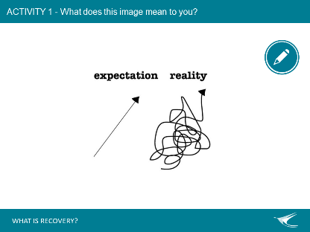  3. | 2 – 8 min  (6 min) | Activity 1 - Question  What does this image mean to you? – Use post-it notes to write what recovery means to you in respect to these two lines. Bring responses to the butcher paper – facilitator to read them out.  Is this your experience or the experience of someone you care for or someone you support?  Recovery is a process, a journey-not a destination, a way of life, an attitude, and a way of approaching the day’s challenges.  It involves trial and error. Does this work or not? Good days and bad days.  Getting to a better life and working to maintain this.  It is not a perfectly linear process.  At times our course is erratic, and we falter, slide back, regroup and start again (Deegan, 1988)  Hope - Recovery provides the essential and motivating message of a better future: that people can and do overcome the barriers and obstacles that confront them. Hope is internalised, but can be fostered by peers, families, friends, providers, community workers, and others. Hope is the catalyst of the recovery process. | Post-it notes  Butchers Paper: What Does Recovery Mean to You?  Markers  Blu Tac
4.  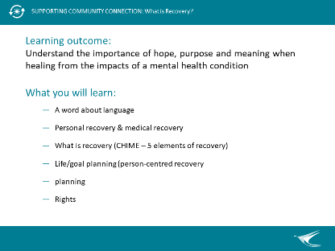 | 8-10 min  (2 min) | Introduce key topic and learning outcome.  Learning outcome: Understand the importance of hope, purpose and meaning when healing from the impacts of a mental health condition  - A word about language  - Personal recovery & medical recovery  - What is recovery (CHIME – a model of recovery, 5 elements of recovery)  - Connectedness  - Hope and optimism  - Identity  - Meaning and purpose  - Empowerment  - Life/goal planning (person-centred recovery planning)  - Rights of people living with a mental health condition  Briefly reference what you will learn and then ask if people have other expectations of this session. Document other expectations on Butchers Paper (this will be revisited at the end of the topic). | Butchers Paper: Other Expectations  Markers
5.  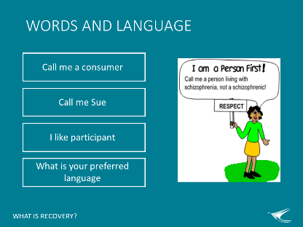 | 10-15 min  (5 min) | Words and language  “Words are important. The language we use and the stories we tell have a great significance to all involved. They can carry a sense of hope and possibility or be associated with a sense of pessimism and low expectations, both of which can influence personal outcomes.”  Devon partnership  Language about mental health has traditionally been used in very negative ways, both intentionally and unintentionally.  Limiting language focusses on difficulties and reinforces powerlessness and hopelessness. It dismisses a person’s experience and their expertise about themselves.  This type of language can impact how the person sees themselves and can cause them to ‘live down’ to the low expectations that are set.  Use inspiring language which promotes hope and their expertise in their own lives. For example:  A person has a goal that you don’t think they can achieve.  What do you say? – Ask for suggestions from room.  Good response can be: How can I support you in taking steps towards this goal?  A person you know tells you they are worried they’ll never work again. What do you say? - Ask for suggestions from room.  Good response can be - What would you need in order to feel ready or able to work again?  Both the above responses give hope for the future to the person and validate that they are the expert in their own lives.  Words and language are critically important in the mental health field where discrimination, disempowerment and loss of self-esteem can cause people to battle with self-stigma.  Consistent with the language of recovery, the following ‘people-first’ language descriptors are used wherever possible:  - ‘person’, ‘people with lived experience’, ‘lived expertise’ and ‘experts by experience’ rather than ‘clients’, ‘service users’ or ‘patients’  - ‘family and support people’, which includes family members, kinship groups, partners, friends or anyone whose primary relationship with the person concerned is a personal, supportive and caring one  - ‘mental health issues’, ‘challenges’ and ‘emotional distress’ are used in place of, and at times alongside, the term ‘mental illness’  - Ask me what I prefer – If you are unsure then ask the person what they prefer.  Refer to the MHCC guide - MHCC Recovery Oriented Language Guide | MHCC Recovery Oriented Language Guide  On the white board write these words:  Hope  Expertise
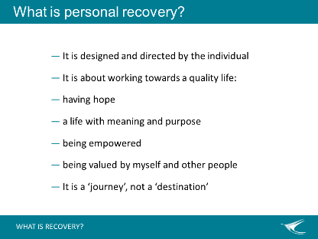  6. | 15–17min  (2 min) | What is personal recovery?  While definitions can vary, most people would agree that recovery is an individual process that is self-defined and driven by the person and their desires and preferences. It is about having hope, valuing yourself and being valued. It is a journey with ups and downs.  [Personal recovery is] a deeply personal, unique process of changing one’s attitudes, values, feelings, goals, skills, and/or roles. It is a way of living a satisfying, hopeful, and contributing life even within the limitations caused by illness. Recovery involves the development of new meaning and purpose in one’s life as one grows beyond the catastrophic effects of mental illness (Anthony, 1993).  The need is to meet the challenge of the disability and to re-find and establish a new and valued sense of integrity and purpose within and beyond the limits of the disability.  The aspiration is to live, work, and love in a community in which one makes a significant contribution (Deegan, 1988)  Recovery is the journey towards a new and valued sense of identity, role and purpose outside the parameters of mental illness; and living well despite any limitations resulting from the illness, its treatment and personal and environmental conditions (Queensland Government position paper, 2005).  Overall, a 2009 literature review indicated that recovery includes:  - The ability to live a meaningful life  - Redefining a positive sense of identity  - Making certain life adjustments  - Overcoming symptoms, stigma and discrimination, and  - Living with hopefulness for the future.  General Question  Hearing these definitions, does this fit with the straight line or the squiggly line?
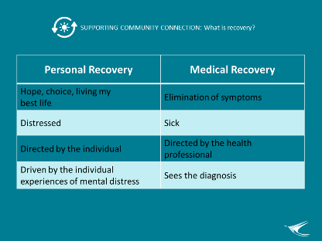  7. | 17-20min  (3 min) | Some people only know about medical recovery. You get sick and then, with or without medical intervention, you get better.  But we are talking about personal recovery.  How is personal recovery different from medical recovery?  - Personal recovery is not focused on the elimination of symptoms  - It does not see distressed people as ‘sick’  - It sees individuals, not generalised diagnoses  - It is not directed by mental health workers or clinicians  One is not better than the other, they are complimentary.  It was identified that what it means to ‘recover’ can be viewed from two different perspectives:  - The medical view of recovery: recovery is a return to a former state of health or ‘cure’. Medical recovery outcomes include medication use and reduced hospitalisation and symptomology.  - The personal view of recovery: recovery is driven by people’s individual experiences of mental distress and recovery. Personal recovery outcomes include empowerment, hope, choice, self-defined goals, healing, wellbeing and control of symptoms.  ‘Clinical recovery is an idea that has emerged from the expertise of mental health professionals, and involves getting rid of symptoms, restoring social functioning, in other words ‘getting back to normal’ [Whereas] Personal recovery is an idea that has emerged from the expertise of people with lived experience of mental illness.’ (Mike Slade, 2009).
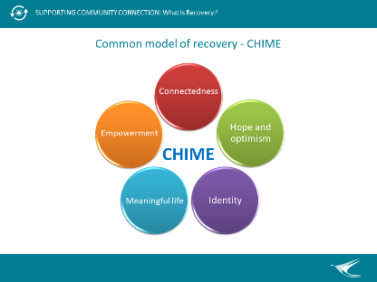  8. | 20-25 min  (5 mins) | CHIME  CHIME is a commonly used model for understanding recovery. There are other models of recovery.  Recovery may be composed of 5 characteristics, summarised by the acronym CHIME. Each letter represents words that explains a critical aspect of recovery.  C - Connectedness – Family, Kinship groups, Relationships, Peer support, supports from others, Being part of the Community  H - Hope and Optimism - Optimism, Belief in Recovery, Motivation, Positive Thinking, Dreams, Aspirations, Hope-inspiring relationships. At times when the person cannot see any positives, it is important that others hold hope and expresses belief in the person and their potential  I - Identity - Start with the person, Connect and build a shared understanding, Support in Rebuilding and Redefining Positive sense of identity and self, overcoming stigma  M - Meaningful life - Making meaning of experiences, may involve spirituality, quality of life, rebuilding a meaningful life and social roles.  E - Empowerment – Support self-management and Personal Responsibility, Control Over own Life, Focus on their Strengths and their Resilience. Positive risk taking.  Ask learners to reflect:  How does this fit in with the services you or your organisation provides?
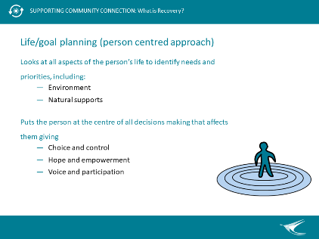  9. | 25-30min  (5 mins) | Life/goal planning  Goal planning is a way to assist a person on their journey. To help them focus and to find and make suitable connections. This is where the community workers, volunteers, peers and others can help a person with their journey.  Planning can involve helping the person with the steps to take to achieve a goal. It can be something you write in an email to the person, or note down on paper, or just discuss with a person.  Life/goal planning:  - Looks at all aspects of the person’s life, to identify needs and priorities  - Environment - the holistic approach can involve looking at the person in the context of their environment, friends, family and community  - Carers, families, friends, kinship groups and other natural supports may be very important allies in the recovery process for consumers  When planning, always use a ‘person-centred approach’  Puts the person at the centre of all decision making that affects them.  - It is about having choice and having control.  - It is empowering.  - It is about encouraging voice and participation.  - It is about holistic, person-driven processes  - Fosters hope and promotes their lived expertise  Person centred Recovery is all about Choice and Control  Self-Defined and Self-Determined – the person chooses what they want to do and what recovery means for them.  Self-Directed and Self-Driven – the person is in control and they set the route, the pace and who will be involved. If they choose, then a worker can go with them on their recovery journey. They can provide information, assistance and support along the way, but they don’t make the decisions.  In person-centred recovery the person is in control and makes all the decisions. They have the POWER!  There is the potential of every person to shape their own life and world.
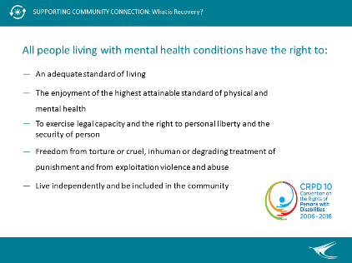  10. | 30-34min  (4 mins) | All people including people living with mental health conditions have the right to:  - an adequate standard of living  - enjoyment of the highest attainable standard of physical and mental health  - exercise legal capacity and the right to personal liberty and the security of person  - freedom from torture or cruel, inhuman or degrading treatment or punishment and from exploitation, violence and abuse  - live independently and be included in the community  It is increasingly recognised that all people living with mental health conditions, whether they have a disability or not, have rights. The above are elements of the UNCRPD (i.e. United Nations Convention on the Rights of Persons with Disabilities, 2007).  You might reference the WHO Quality Rights Manual/framework which Australia has been, and will hopefully continuing to be, undertaking a lot of work around against these five rights over the next few years.  In simple terms the basic ideas are:  - People are free to make their own choices  - No one will be discriminated against  - Disabled people have the same rights to be included in society as anybody else  - Disabled people are to be respected for who they are  - Everyone should have equal opportunities.  Everyone should have equal access.
11.  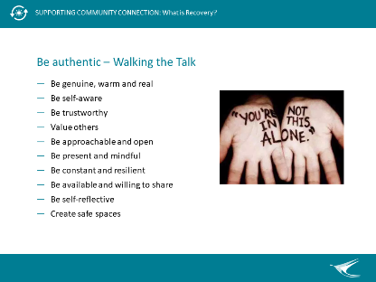 | 34-37min  (3 mins) | To help or stand beside someone when healing from the impacts of a mental health condition, you need to be authentic and ‘walk the talk’.  Being authentic – Walking the Talk  - Be genuine, warm and real  - Be self-aware  - Be trustworthy  - Value others  - Be approachable and open  - Be present and mindful  - Be constant and resilient  - Be available and willing to share  - Be self-reflective  - Create safe spaces
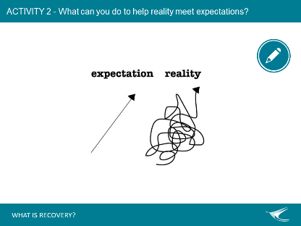  12. | 37-43  (6 min) | ACTIVITY 2  Ask participants to think about how they can help a person’s reality meet with their expectations. This may also include things they have learned today.  Use post-it notes to attach to butcher paper.  Read some of the suggestions out to the room, then summarise with:  You yourself can be the best support  Just be yourself – do not need mental health knowledge or experience. | Butchers Paper: Recovery - Meeting Expectations
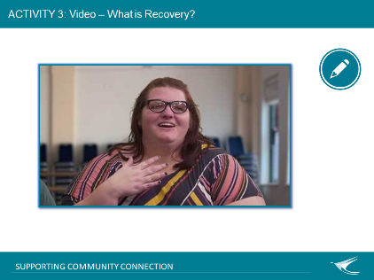  13. | 43-53 min  (10 min) | ACTIVITY 3  Show and discuss video.  For discussion: How are the experiences of Community Workers and other supporters (paid or unpaid) in this video related to the importance of hope, purpose and meaning when healing from the impacts of a mental health condition? | Video embedded in PPT  Back-up internet access to videos (MHCC webpage)  Audio speakers (as required)
14.  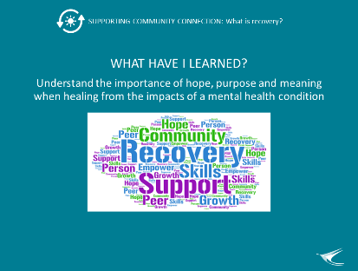 | 53-60 min  (7 min) | Revisit whether we achieved the learning outcome for this topic: The importance of hope, purpose and meaning when healing from the impacts of a mental health condition? (and also see slide 4).  Remind learners that we started off by exploring what recovery means to you? And whether your experience is the wiggly or straight line.  Explore if the ‘What is Recovery?’ key topic content supported achieving the learning outcome and other expectations of this session that were put on Butchers Paper earlier. | Revisit posted Butchers Paper from the beginning of the topic: ‘Other Expectations’  Revisit posted Butchers Paper from the beginning of the topic: ‘What Does Recovery Mean to You?’
15.  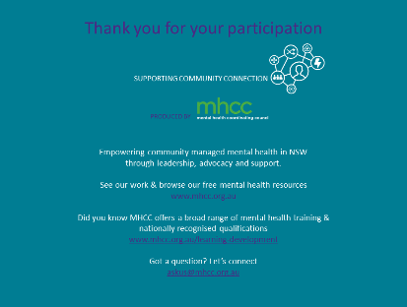 |  | Acknowledge MHCC’s development of the learning resource and encourage others to learn more about who MHCC is and what they do:  - Peak body for the community managed mental health sector in NSW  - Registered training organisation.

